MT-SMS (Mobile-Terminated SMS)

📥 What Is MT-SMS (Mobile-Terminated SMS)?
# Source: AI Source: Provided by: [Data Path: Persons Table -> ID Column: 1, Name_En Column: Motasem Essam] -> From: [ChatGPT] on [1/21/2026]
MT-SMS stands for Mobile-Terminated Short Message Service.
It refers to an SMS message that is delivered to a mobile device from an external source — such as another phone, an SMS application, or a service provider.
🧠 It’s called "terminated" because the SMS ends (terminates) at the mobile user’s device.

📲 Example Scenarios:
# Source: AI Source: Provided by: [Data Path: Persons Table -> ID Column: 1, Name_En Column: Motasem Essam] -> From: [ChatGPT] on [1/21/2026]
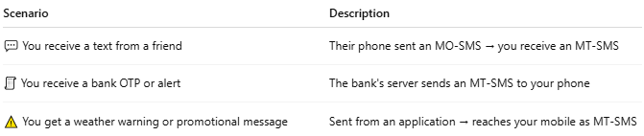

Scenario | Description
💬 You receive a text from a friend | Their phone sent an MO-SMS → you receive an MT-SMS
🧾 You receive a bank OTP or alert | The bank's server sends an MT-SMS to your phone
⚠️ You get a weather warning or promotional message | Sent from an application → reaches your mobile as MT-SMS

🔁 MT-SMS Flow (Simplified):
# Source: AI Source: Provided by: [Data Path: Persons Table -> ID Column: 1, Name_En Column: Motasem Essam] -> From: [ChatGPT] on [1/21/2026]
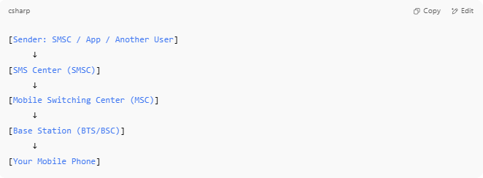

[Sender: SMSC / App / Another User]
↓
[SMS Center (SMSC)]
↓
[Mobile Switching Center (MSC)]
↓
[Base Station (BTS/BSC)]
↓
[Your Mobile Phone]

🔍 Key Features of MT-SMS:
# Source: AI Source: Provided by: [Data Path: Persons Table -> ID Column: 1, Name_En Column: Motasem Essam] -> From: [ChatGPT] on [1/21/2026]
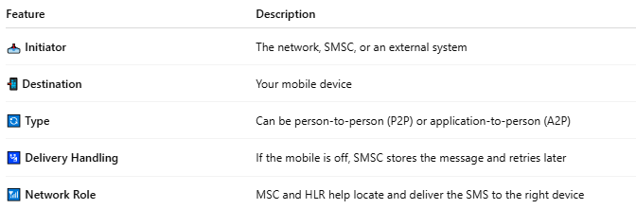

Feature | Description
📥 Initiator | The network, SMSC, or an external system
📲 Destination | Your mobile device
🔄 Type | Can be person-to-person (P2P) or application-to-person (A2P)
🛂 Delivery Handling | If the mobile is off, SMSC stores the message and retries later
📶 Network Role | MSC and HLR help locate and deliver the SMS to the right device

🆚 MO-SMS vs MT-SMS:
# Source: AI Source: Provided by: [Data Path: Persons Table -> ID Column: 1, Name_En Column: Motasem Essam] -> From: [ChatGPT] on [1/21/2026]
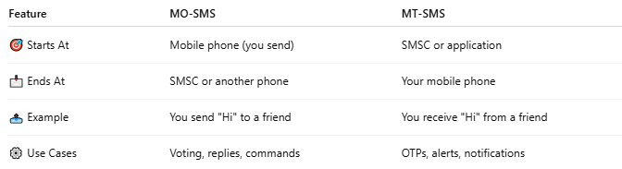

Feature | MO-SMS | MT-SMS
🎯 Starts At | Mobile phone (you send) | SMSC or application
📩 Ends At | SMSC or another phone | Your mobile phone
📤 Example | You send "Hi" to a friend | You receive "Hi" from a friend
⚙️ Use Cases | Voting, replies, commands | OTPs, alerts, notifications

📖 Summary:
# Source: AI Source: Provided by: [Data Path: Persons Table -> ID Column: 1, Name_En Column: Motasem Essam] -> From: [ChatGPT] on [1/21/2026]
- MT-SMS = SMS delivered to your phone
- Can be from another user (P2P) or a service/application (A2P)
- Handled by the network and SMSC, often with delivery reports

